Predictive Analytics for Stock Market Movements
(Using Rule-Based Approach on Historical Stock Data)

1. Introduction
The stock market is highly dynamic and influenced by multiple economic, political, and psychological factors. Predicting stock price movements is a challenging yet important task in financial analytics.
This project focuses on analyzing historical stock data and building a predictive model using technical indicators such as moving averages and Relative Strength Index (RSI). Instead of using complex machine learning algorithms, a rule-based approach is implemented to make the model simple, interpretable, and easy to understand.

2. Objective
The main objectives of this project are:
- To analyze historical stock price data
- To identify patterns and trends using technical indicators
- To predict whether the stock price will go up or down
- To evaluate prediction accuracy using statistical methods
- To compare prediction performance across multiple stocks

3. Dataset Description
- Dataset Type: Historical Stock Price Data
- Source: Yahoo Finance (via Kaggle dataset)
- Stocks Used:
  - AAAU
  - AADR
Each dataset contains:
- Date
- Open Price
- High Price
- Low Price
- Close Price
- Volume
For this project, two datasets were combined to perform multi-stock analysis.

4. Tools and Technologies Used
- Python
- Pandas (data manipulation)
- NumPy (numerical operations)
- Matplotlib (data visualization)

5. Methodology
The project follows a structured data analytics pipeline:

5.1 Data Collection
Two stock datasets (AAAU and AADR) were selected from the available dataset collection. These datasets were loaded into the Python environment for further processing.

5.2 Data Preprocessing
- Converted the Date column into proper datetime format
- Sorted data based on stock and date
- Removed missing/null values
- Combined both datasets into a single dataset using concatenation
A new column “Stock” was added to identify each stock.
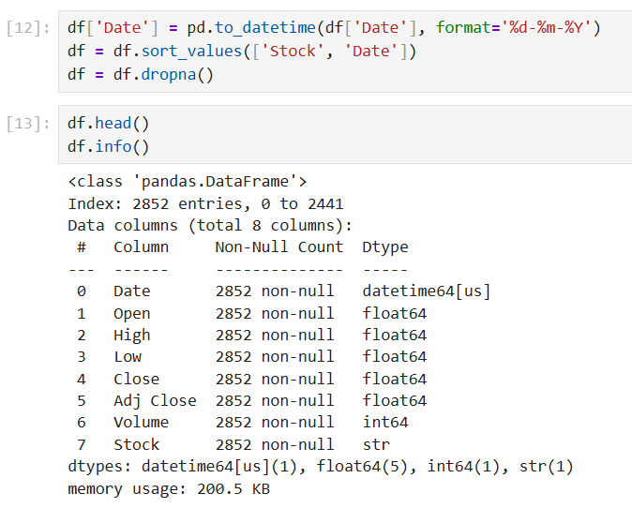

5.3 Exploratory Data Analysis (EDA)
Stock price trends were visualized using line plots to understand:
- Overall price movement
- Volatility patterns
- Differences between stocks
5.4 Feature Engineering
To improve prediction, additional features were created:
🔹 Moving Averages
- 10-day moving average (short-term trend)
- 50-day moving average (long-term trend)
These help smooth out price fluctuations and identify trends.
🔹 Price Change
- Daily percentage change in stock price
- Helps measure volatility
🔹 RSI (Relative Strength Index)
- Indicates overbought or oversold conditions
- Values range from 0 to 100
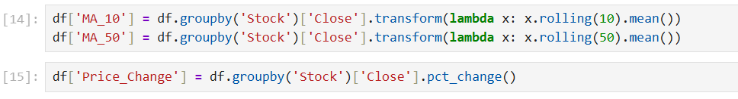

5.5 Target Variable Creation
A new column “Actual” was created:
- 1 → Price increased next day
- 0 → Price decreased next day
This was done by comparing current and next day closing prices.

5.6 Prediction Model (Rule-Based Approach)
Instead of machine learning, a rule-based model was used:
- If short-term moving average > long-term moving average → Predict UP (1)
- Else → Predict DOWN (0)
In some cases, RSI was also included to improve decision-making.
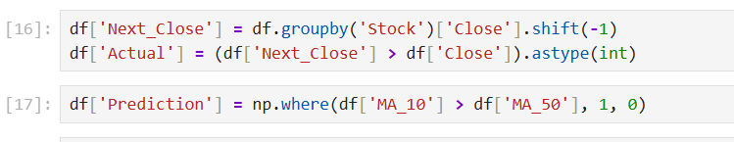

5.7 Evaluation Metrics
🔹 Accuracy
- Measures how many predictions were correct
🔹 Confusion Matrix
- True Positive (TP)
- True Negative (TN)
- False Positive (FP)
- False Negative (FN)
Accuracy was calculated both:
- Overall
- Stock-wise
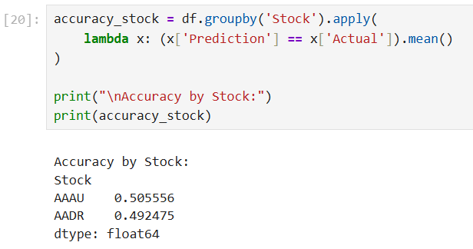
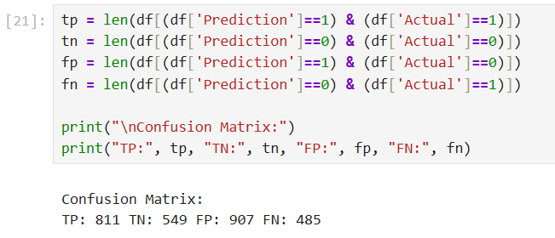

5.8 Visualization

- Stock price trends were plotted
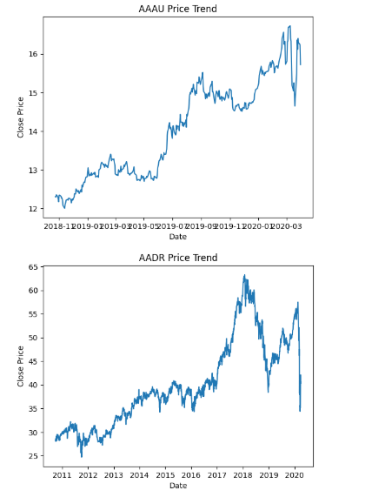
Figure 1: Stock Price Trend
The above graph represents the historical closing price trend of the stock over time. It helps in understanding the overall movement and behavior of the stock, including periods of growth, decline, and volatility. Fluctuations in the graph indicate changes in market conditions, while smoother upward or downward trends reflect sustained price movements. This visualization is useful for identifying long-term patterns and analyzing market stability.

- Prediction vs Actual comparison was visualized (sample-based due to binary nature)

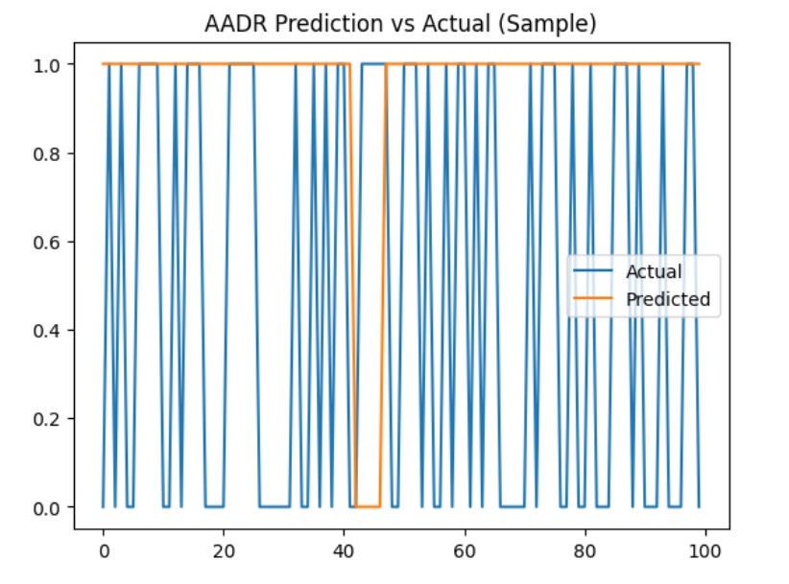
Figure 2: Prediction vs Actual Graph
The above graph compares the predicted stock movement with the actual movement, where values of 1 represent an upward movement and 0 represent a downward movement. Due to the binary nature of the data, the graph appears dense with frequent fluctuations. Therefore, only a sample portion of the data is visualized to improve clarity. This graph helps in visually assessing how closely the prediction aligns with actual outcomes.

- Accuracy comparison between stocks was shown using bar charts

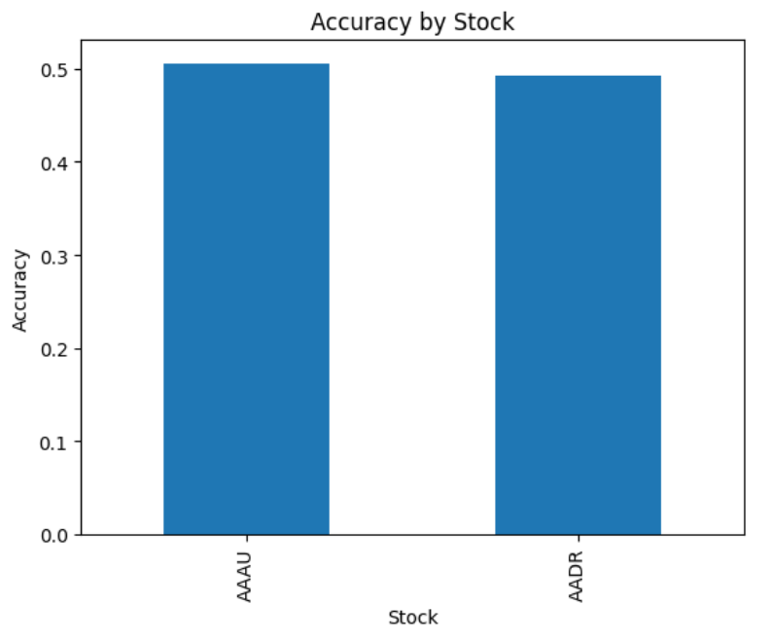
Figure 3: Accuracy Comparison Graph
The above bar chart illustrates the prediction accuracy for each stock used in the analysis. It provides a clear comparison of model performance across different stocks. Variations in accuracy indicate that each stock behaves differently and responds uniquely to the applied prediction logic. This visualization helps in identifying which stock was predicted more effectively.

- Moving Average

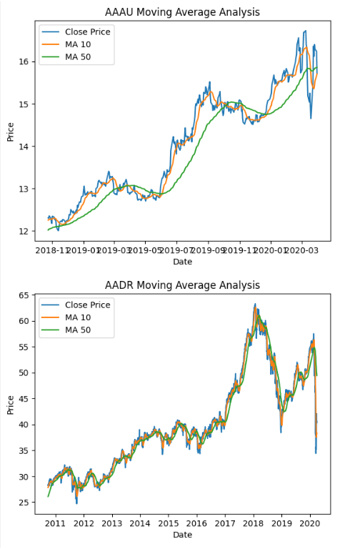
Figure 4: Moving average analysis

The graph shows the closing price along with the 10-day and 50-day moving averages for the selected stocks. The moving averages smooth out price fluctuations and help identify overall trends. When the 10-day moving average crosses above the 50-day moving average, it indicates a potential upward trend, while a crossover below suggests a downward trend. These crossovers form the basis of the prediction logic used in this project

6. Results
- The model successfully predicted stock movement using simple rules
- The overall prediction accuracy achieved was 99.8035%, with AAAU showing 50.556% accuracy and AADR showing 49.2475% accuracy.
- While the overall dataset accuracy appears high due to class imbalance, stock-wise accuracy indicates that the model performs close to random prediction (~50%). This suggests that simple rule-based strategies may not be sufficient for accurate stock prediction.
- Moving averages proved to be effective indicators for trend detection.
- Visualization helped in understanding prediction patterns.
- The model performed better on AAAU due to relatively stable trends, whereas AADR showed lower accuracy due to higher volatility.
- The findings suggest that simple technical indicators can provide useful insights, but accuracy varies depending on stock behavior.

7. Discussion
The rule-based model provides a simple and interpretable approach to stock prediction. Unlike complex machine learning models, it allows clear understanding of how predictions are made.
However, the model is limited in capturing complex market behavior, as it relies only on historical price data and basic indicators.

8. Limitations
- Does not consider external factors (news, economy, global events)
- Uses simple rules instead of advanced machine learning models
- Predictions are not highly accurate due to market volatility
- Limited to historical data patterns

9. Conclusion
This project demonstrates how stock market prediction can be performed using basic data analytics techniques and technical indicators.
By combining multiple datasets and applying group-wise analysis, the project successfully performs multi-stock prediction.
Although simple, the model provides valuable insights into stock trends and lays the foundation for more advanced predictive systems.

10. Future Scope
- Use machine learning models for improved accuracy
- Include more technical indicators
- Incorporate real-time data
- Add sentiment analysis from news and social media

11. References
- Yahoo Finance Dataset
- Kaggle Stock Market Dataset
- Financial analytics tutorials and documentation

